Boat Yard Services

Booking Guide

Members can now book a variety of services directly via the Harbour Assist Portal. These services include:

- Standard Yard Space
  - This is suitable for boats up to 10m in length.
  - It includes a lift out and back in (NB. Not available at weekends).
  - Up to 30 days in the yard.
  - Available to book up to 60 days in advance.

- Large Yard Space
  - Suitable for boats over 10m in length.
  - Service includes lift out and back in (NB. Not available at weekends).
  - Up to 30 days in the yard.
  - Available to book up to 60 days in advance.

- Lunch-time lift out
  - Suitable for all boats kept within the marina.
  - Service includes a 1-hour lift in the hoist.
  - This service is Free of charge.
  - Add-on service available – boat wash off @ £28.5
  - NOTE – Member must contact the Yard office at 11:00 on the day of lift. Lift will be done at approximately 12:30 to be returned to the water by 13:30~.
  - Time extensions are not available. Boat must be cleared from slipway immediately.
  - Failure to present boat on time may result in booking being cancelled. Refunds will not be provided in these circumstances.

- Overnight Sling – Weekdays.
  - Suitable for all boats kept within the marina.
  - Service includes an overnight lift in the sling.
  - NOTE – Member must present boat at slipway between 16:00-16:15. Lift will be done by 16:30. Boat to remain in sling overnight and returned to the water by 10am on the following day.
  - Time extensions are not available. Boat must be cleared from slipway immediately following lift in.
  - Failure to present boat on time may result in booking being cancelled. Refunds will not be provided in these circumstances.

- Weekend Sling
  - Suitable for all boats kept within the marina.
  - Service includes an overnight lift in the sling.
  - Add-on service available – boat wash off @ £25
  - NOTE – Member must present boat at slipway between 15:30-15:45 on Friday afternoon. Lift will be done by 16:30. Boat to remain in sling over the weekend and returned to the water by 10am on the following Monday.
  - Time extensions are not available. Boat must be cleared from slipway immediately following lift in.
  - Failure to present boat on time may result in booking being cancelled. Refunds will not be provided in these circumstances.

SECTION 1 - How to access the Harbour Assist Portal
If you are an existing user or have previously registered, then please skip to Section 2.
Members can access the portal by clicking the following link or copying it and pasting into web browser;
https://cbyc.harbourassist.com/portal
You will need to register before you can use the portal. Click on the green ‘Register’ button.
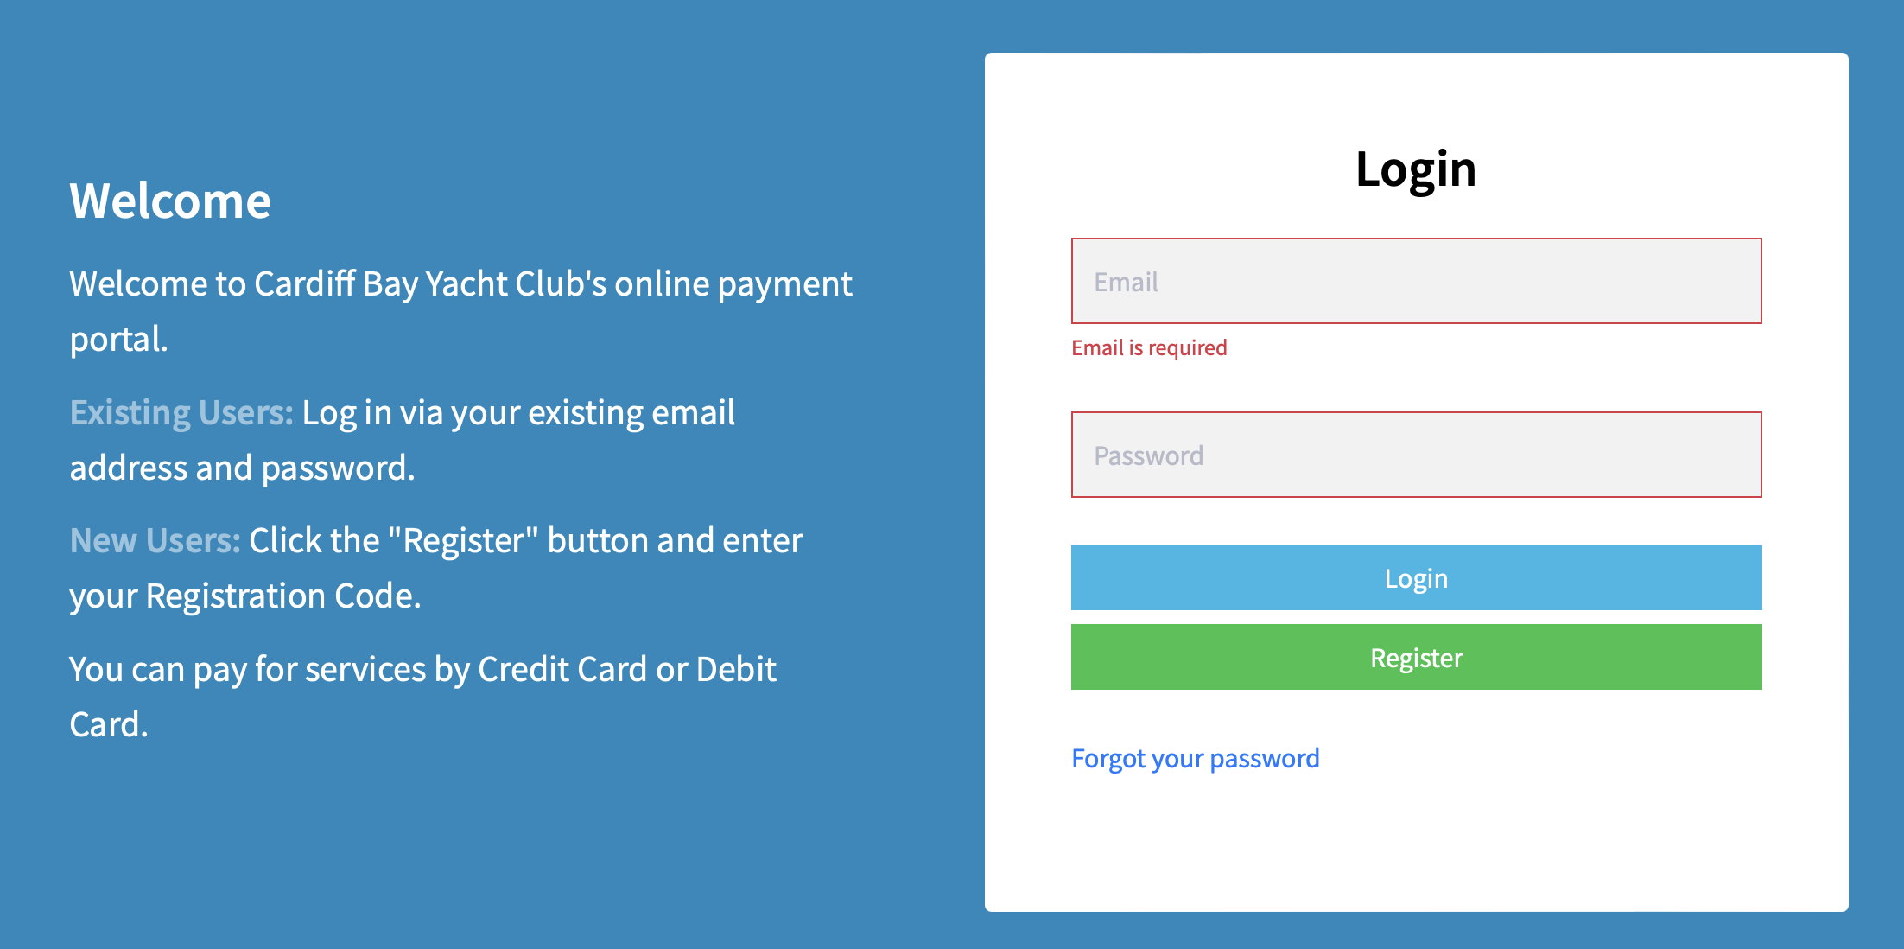
You will be asked to enter your ‘Registration Token’. Each member has a unique code which can be found in the ‘How to pay’ section at the bottom of any club invoice.
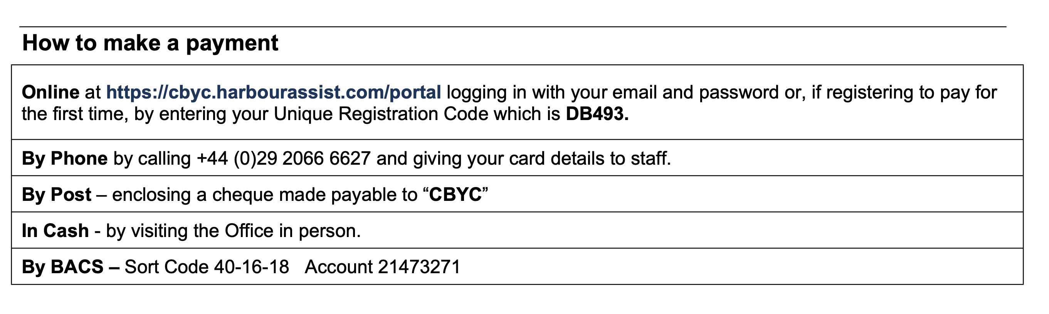
Enter your code and click ‘Next’.
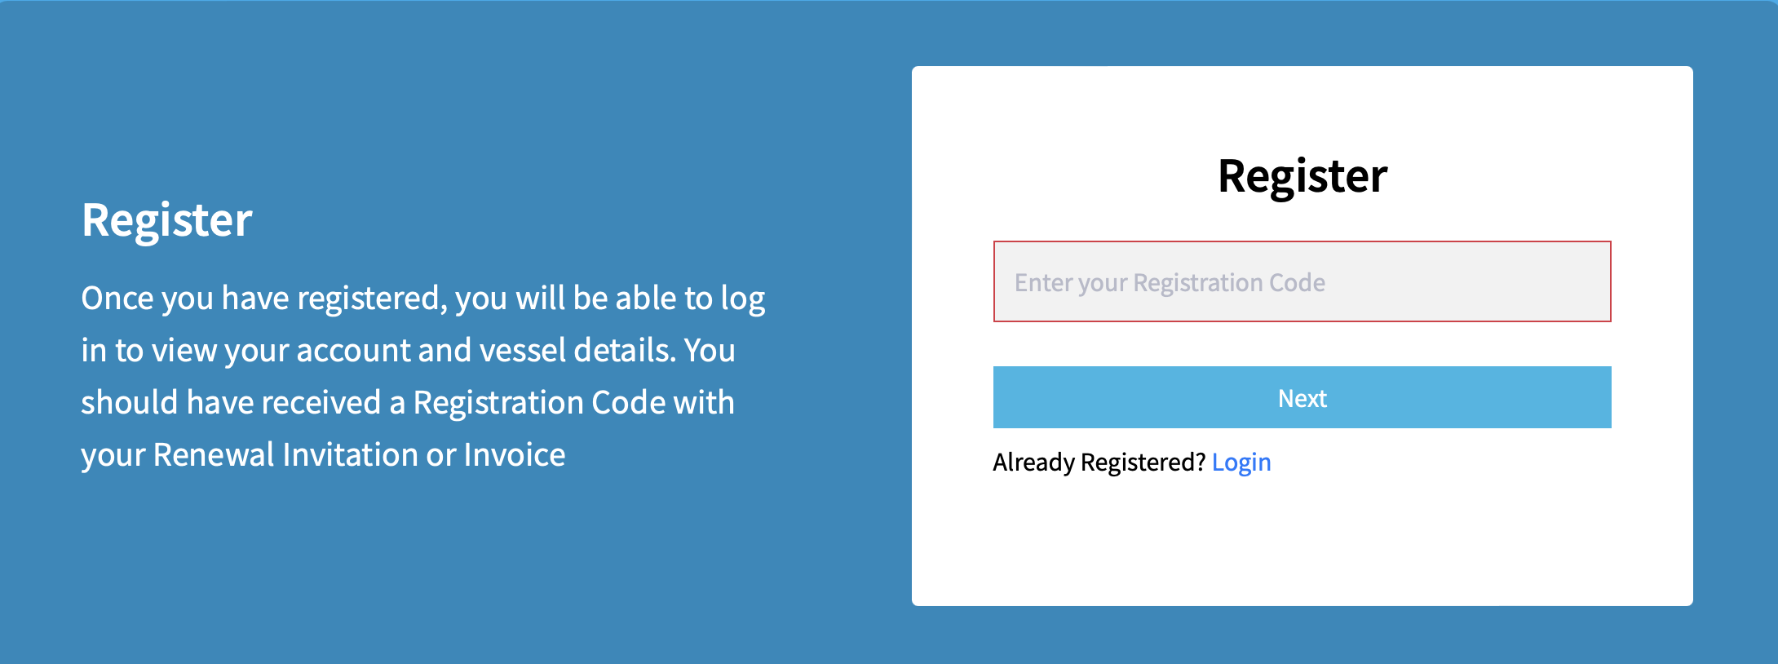
You will then be required to create a new password. Please make sure your chosen password conforms to the requirement set out below.
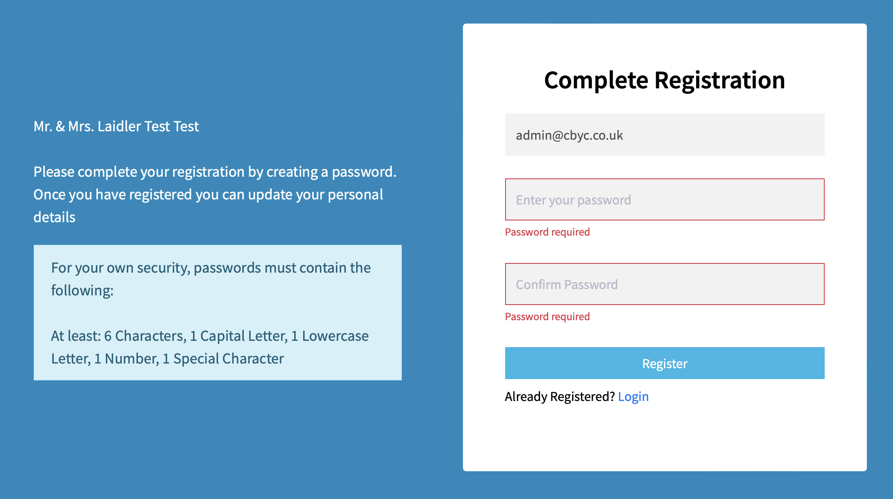
Once registered the portal will log you in to your account. Members can use this portal to view your account details, view and pay invoices, contact us with queries and book the various services offered by the club.

SECTION 2 – How to make a booking.

To make a booking for yard services follow these simple steps:

- Please select ‘Booking Requests’ here.
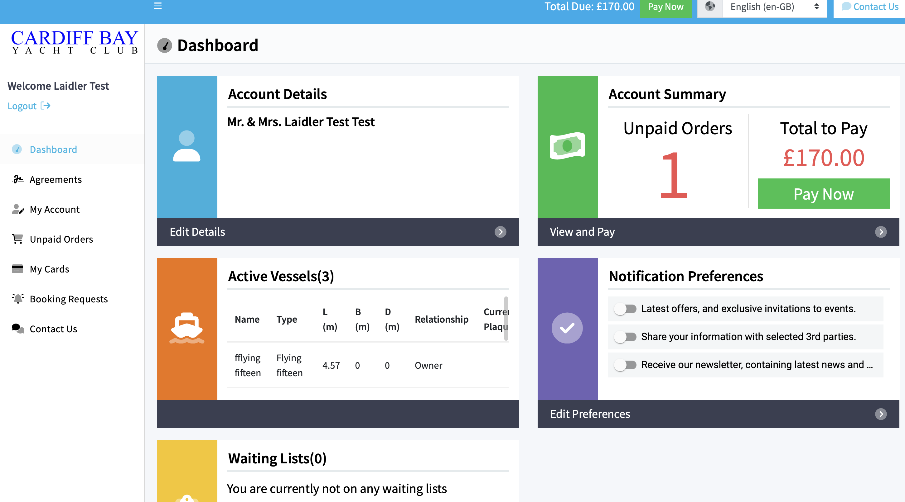

- Select the service you require.

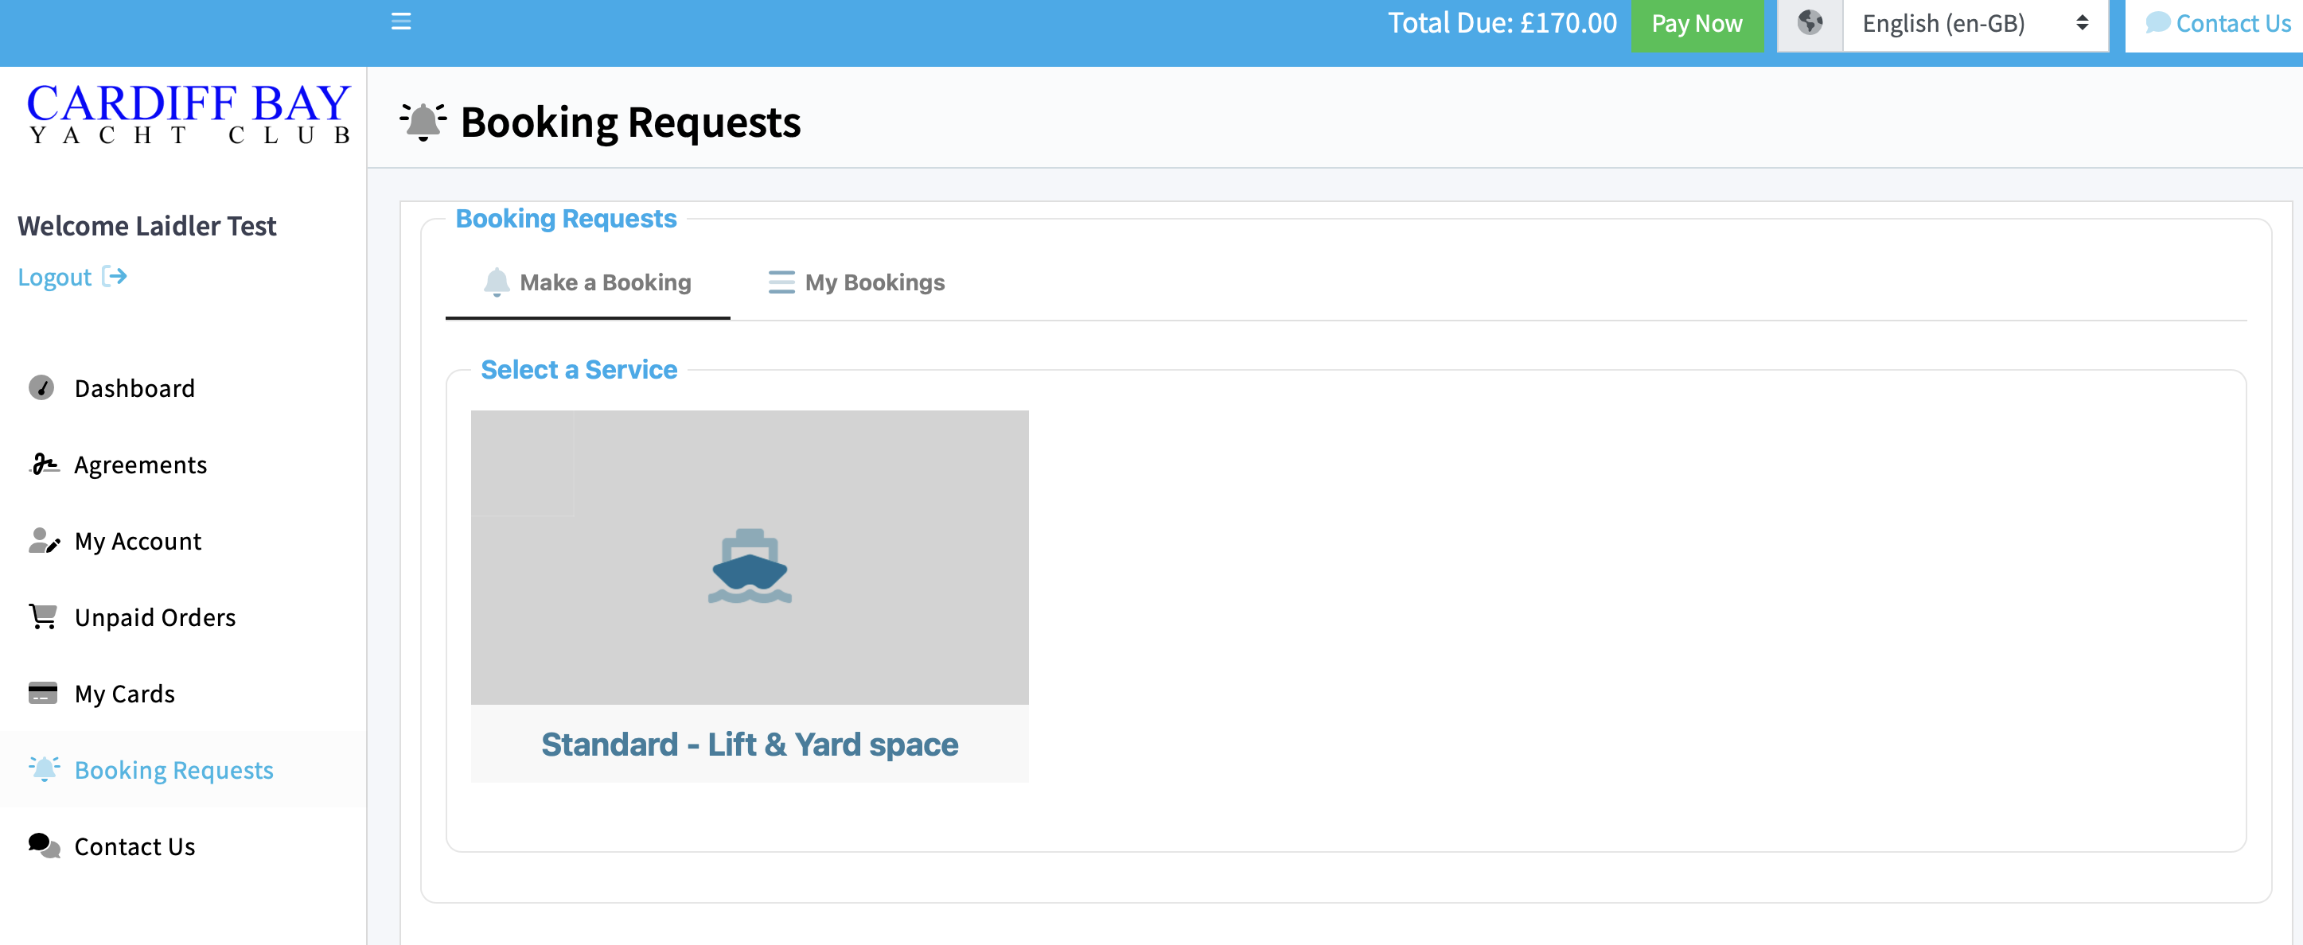

- Select the date you require the service. For yard bookings you will need to select a start date and end date. Please note the booking restrictions at the bottom of the screen.
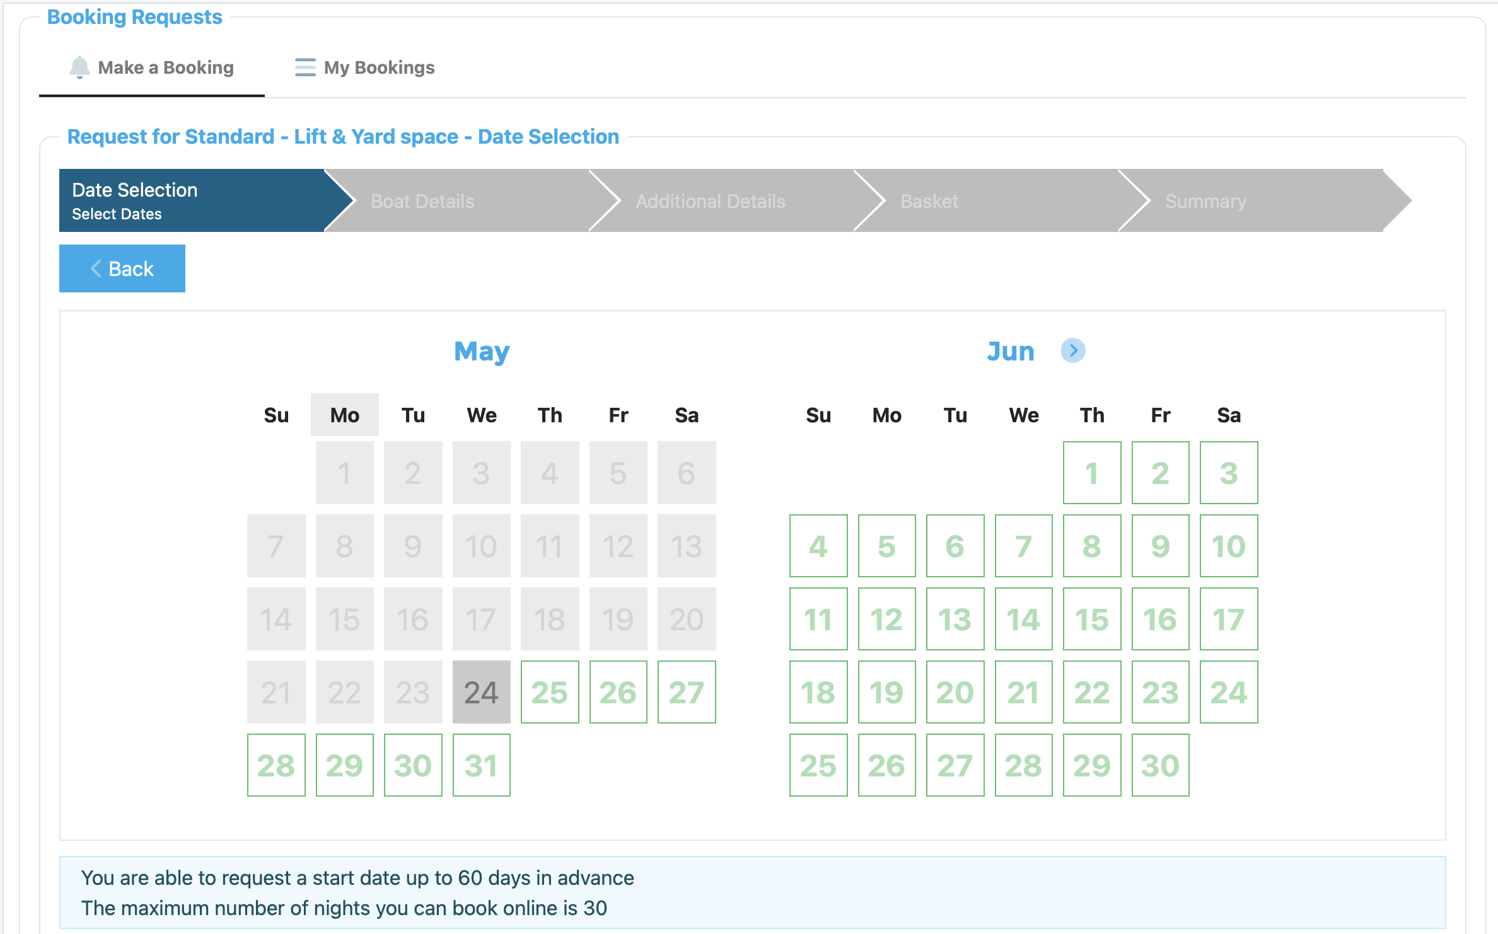
- Choose which boat you require the service for by clicking the ‘Select’ button adjacent to the correct boat. (Most members on have one boat listed on their account)

Then Click ‘Next’.

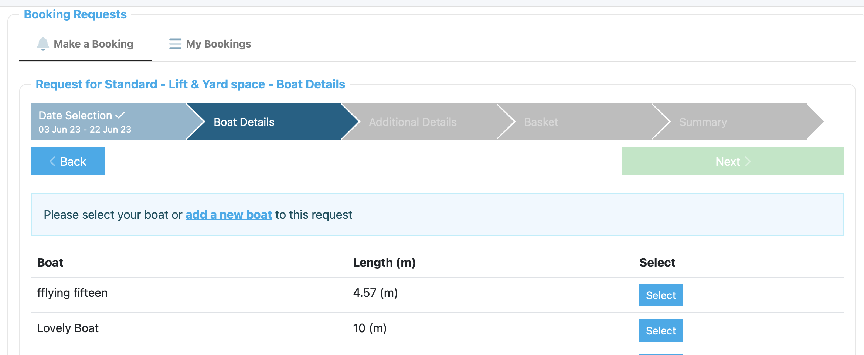

- Please add any missing details about your boat. These are highlighted with red boxes. Then click ‘Next’.

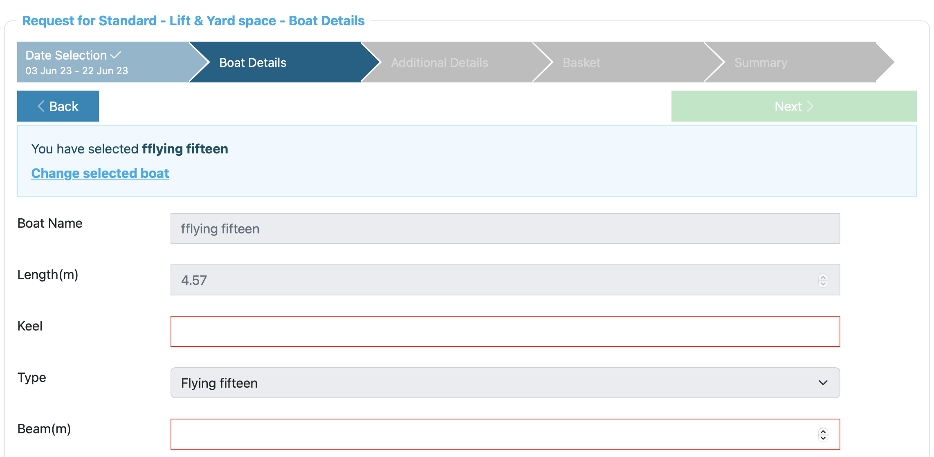

- Please provide a short summary of the work to be undertaken and then click ‘Next’.
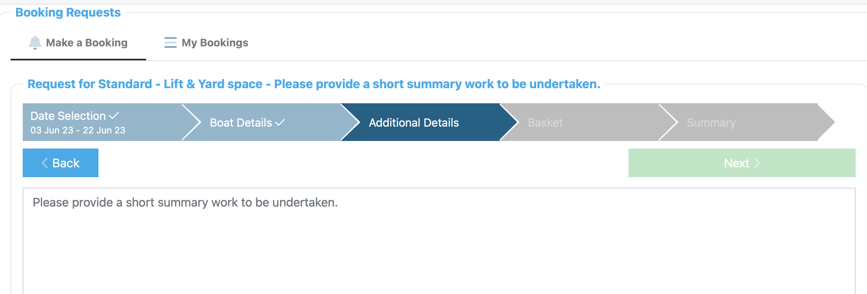

- You will then be shown a summary of your booking including the associated cost.

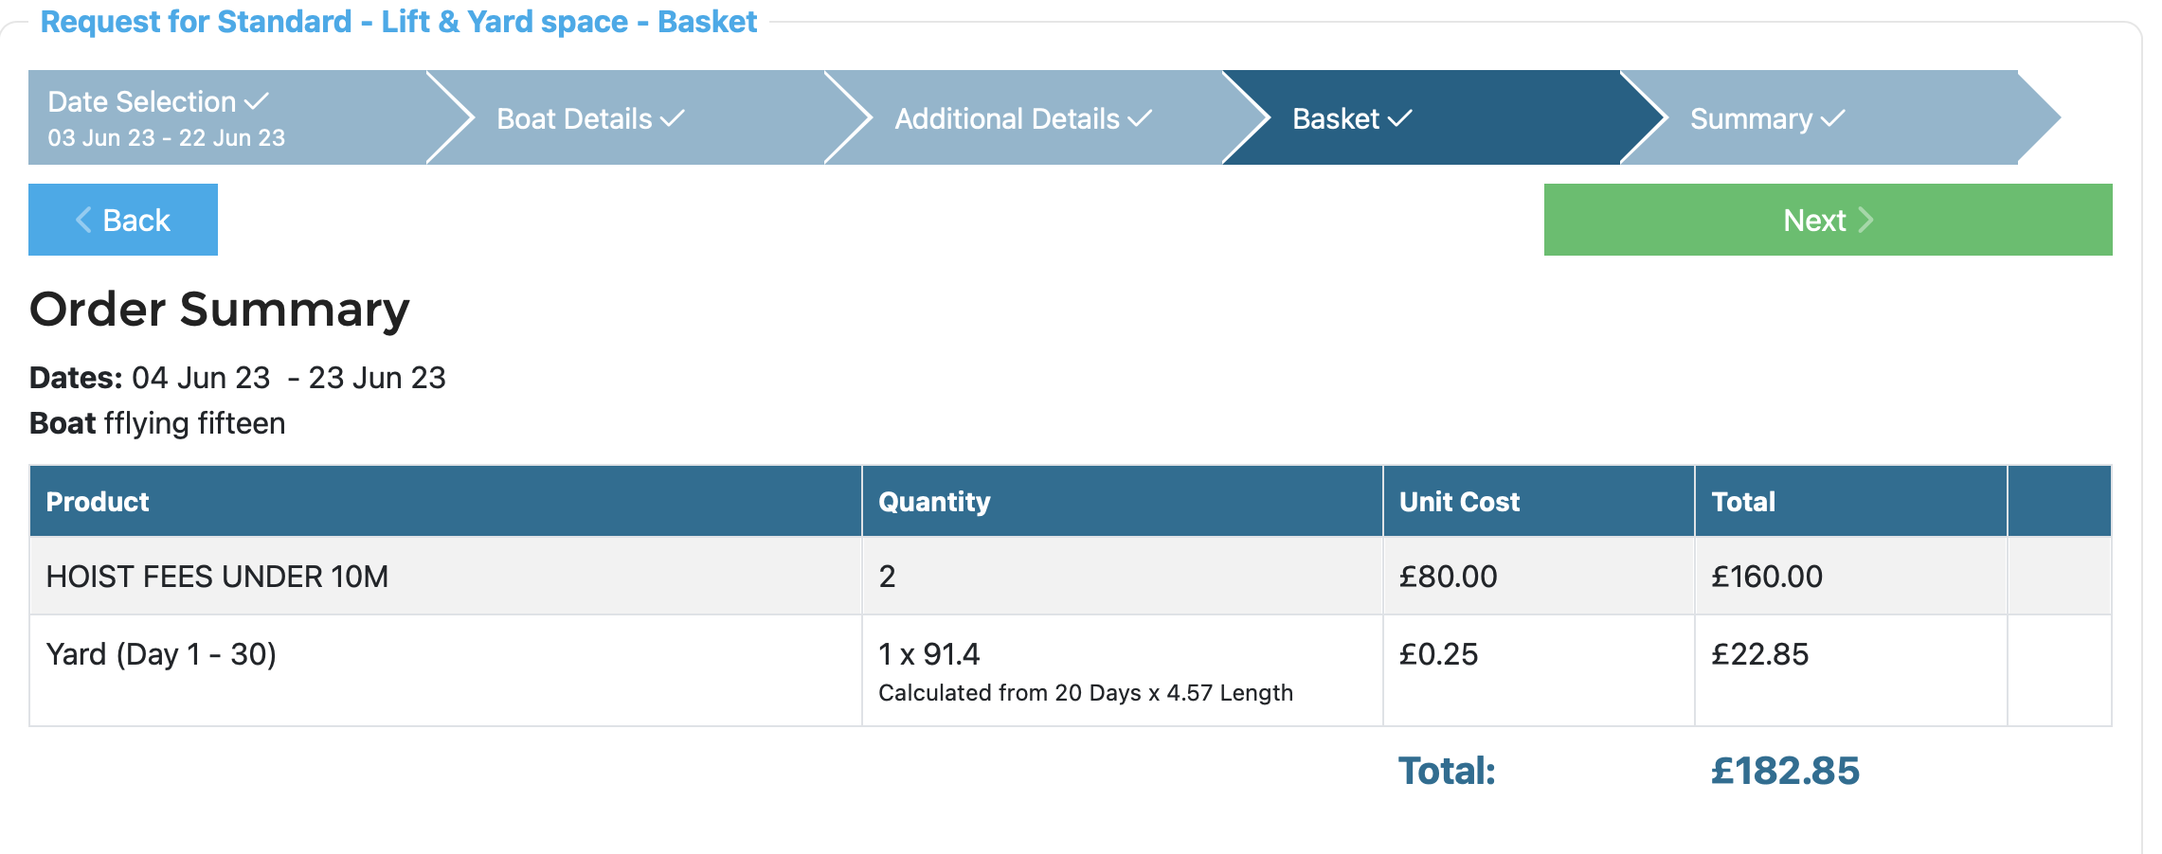

Please check the details. If you need to make amendments, then you can click ‘Back’ and edit the booking as required. Once satisfied, please click ‘Next’.

- To confirm the booking, please select ‘Submit & Pay’.

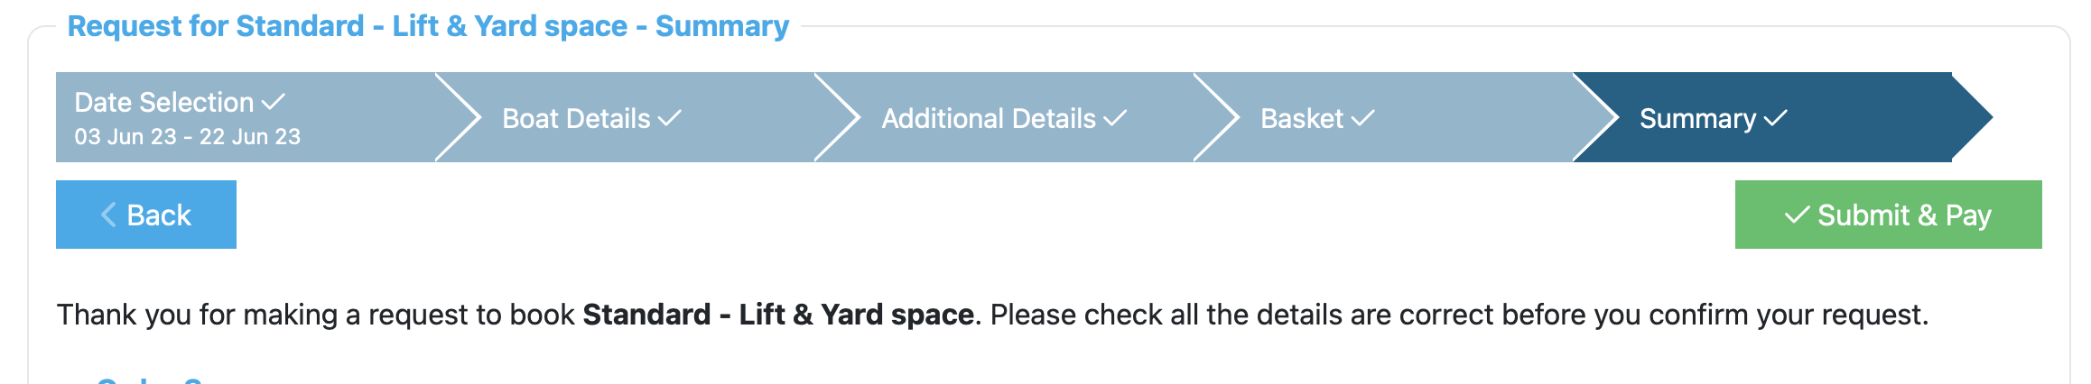

- You will then be directed to the payment screen. Please make payment via the portal by clicking ‘checkout’ at the bottom of the screen and following the onscreen instructions.

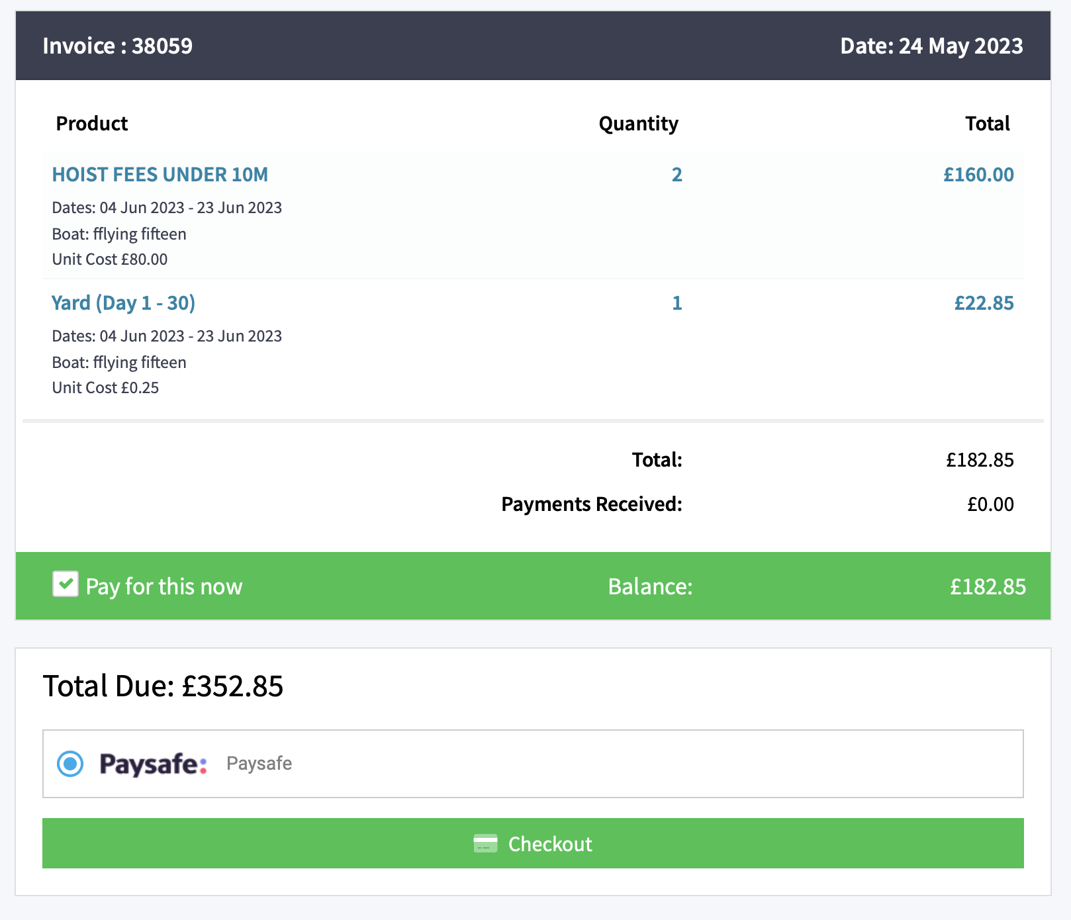
- The portal will then submit your request for review and final approval and send you confirmation that your request has been received. Once scheduled in the diary you will receive a second email to finalise the booking.

Terms & Conditions

- BOOKINGS
  - All services are subject to availability.
  - CBYC reserves the right to withdraw booking service without notice.
  - CBYC reserves the right to amend or cancel bookings at any time.
  - The booking system is a self-service facility and Members must register on the Harbour Assist portal.
  - Where boats are not presented on time booking may be cancelled and fee forfeited.

- PAYMENT
  - Payment must be made at the time of booking.
  - Bookings will not be confirmed until payment is made in full.
  - Any unpaid orders will automatically be cancelled after 7 days, and the member will need to rebook.
  - Partial refunds will not be provided if boats return to the water faster than planned.
  - Boats overstaying the duration of existing booking will be returned to the water where possible. If it is not possible to safely return the boat to the water, the member will incur Penalty fees at a rate of £2.20 per metre per day.

- CANCELLATION
  - Members may cancel their booking up to 7 days before the schedule date. A full refund will be issued.
  - Cancellation with less than 7 days’ notice will not receive refund.
  - Where bookings are cancelled by the club, service will be rescheduled, or a full refund will be provided. The club does accept responsibility for incidental loss relating to third party costs.

- Other
  - Members must not apply paint/anti-foul near the hoist strops.
  - CBYC reserves the right to amend terms and conditions without prior notice/

