
LOCAL NOTICE TO MARINERS No. 16 OF 2025

Hinkley Point C Marine Works Offshore Area

Fish Return System Offshore Outfall Head
and Tunnel Ramp Installation

Issued 04/11/2025

Mariners are advised that from 01/11/25 till 31/03/26, the vessels listed in the below table will be engaged in the installation of an outfall head and tunnel ramp works. This activity forms part of the HPC – Fish Return System offshore scope to allow for the installation of the concrete outfall tunnel headwall structure.

There will be durations at which divers will be in attendance to support the works and International Maritime Signal Flag Alpha will be deployed at these times.

At times when the Maritime Signal Flag Alpha is deployed, a 500m Clearance Safety Zone will be in place around the dive vessel/platform.

List of Vessels and details are as per below:

Name | Type of Vessel | Call Sign | MMSI Number | Length(m)
Haven Sea Challenger | JUB | MJQJ2 | 232037256 | 50.0
JU36201 | JUB | PCAY | 244099000 | 36.5
JU2417 | JUB | N/A | N/A | 24.4
Ocean Energy | Works Vessel - Tug | MNKI5 | 232046909 | 23.3
Willchallenge | Works Vessel - Tug | MIPS7 | 232033014 | 22.0
Ocean Shoalbuster | Works Vessel - Tug | MGLQ2 | 235021947 | 26.2
Ocean Transfer | Crew Transfer Vessel | MDNG8 | 232016908 | 7.4
Celtic Guardian | Crew Transfer Vessel | 21ZH5 | 235114006 | 13.9
Nearshore Explorer | Survey Vessel | MGHD9 | 235021512 | 19.5
Capall Mara | Spud barge / Backhoe Dredger | MBSF3 | 232010652 | 39.6
Wind Lass | Works Vessel - Tug | 2EZQ4 | 235089425 | 26.0

Location Plan: Q(3)G.6s - Admiralty 1152

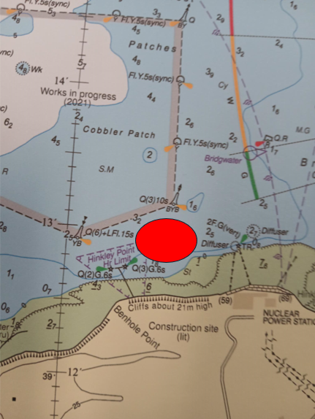

List of Figures:

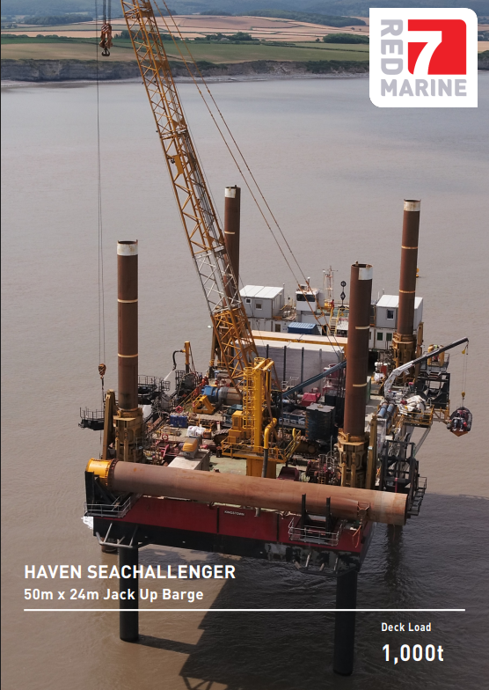
Figure 1: Haven SeaChallenger
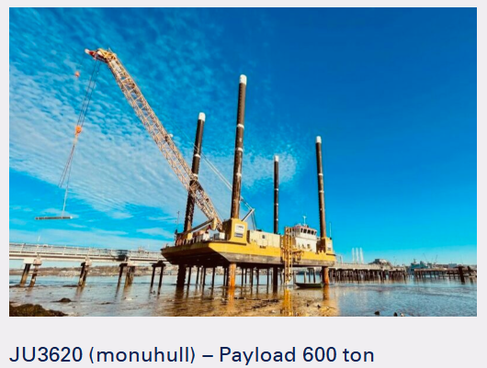
Figure 2: JU3620 JUB
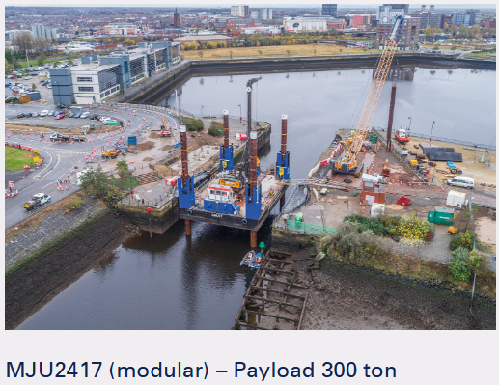
Figure 3: JU2417 JUB

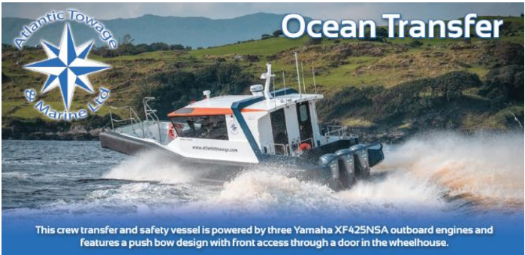
Figure 4: Ocean Transfer
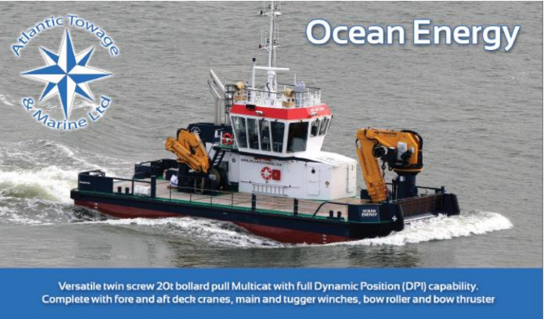
Figure 5: Ocean Energy
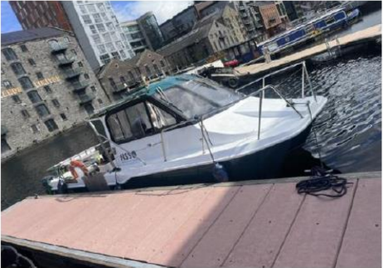
Figure 6: Nearshore Explorer Survey Vessel
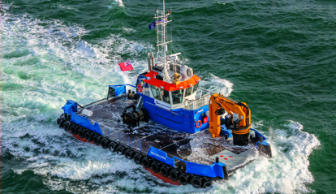
Figure 7: Willchallenge
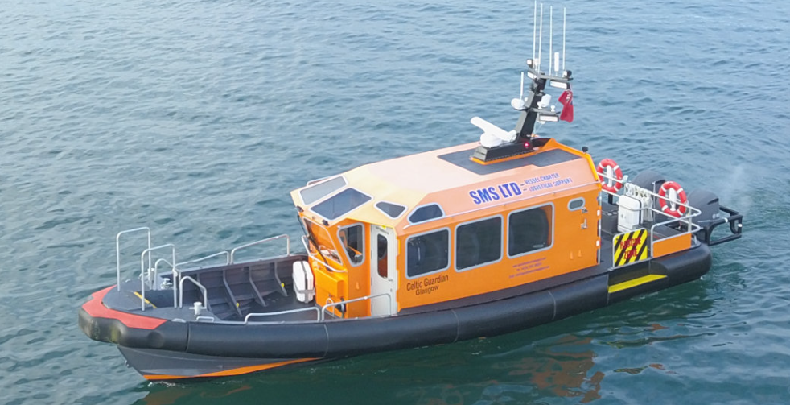
Figure 8: Celtic Guardian
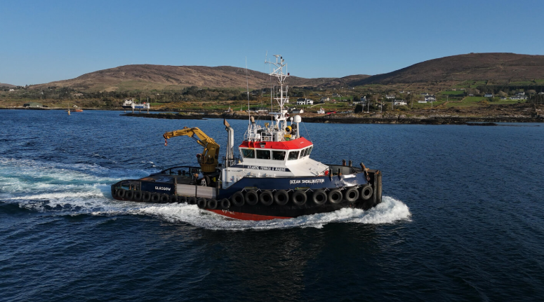
Figure 9: Ocean Shoalbuster

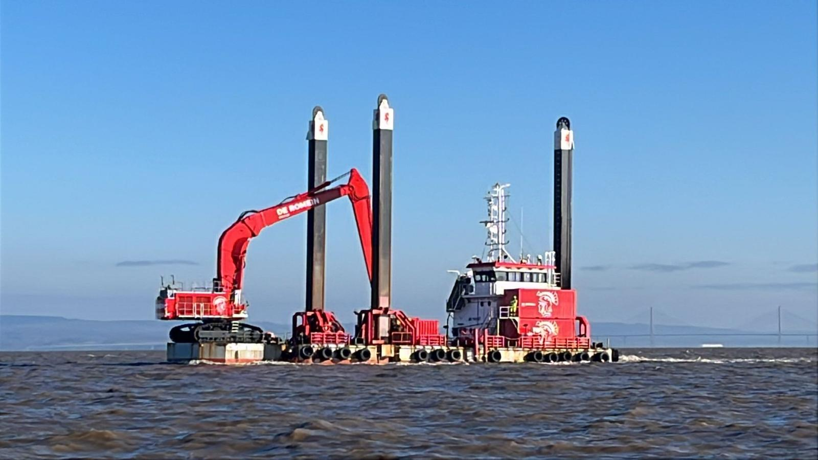
Figure 10: Capall Mara
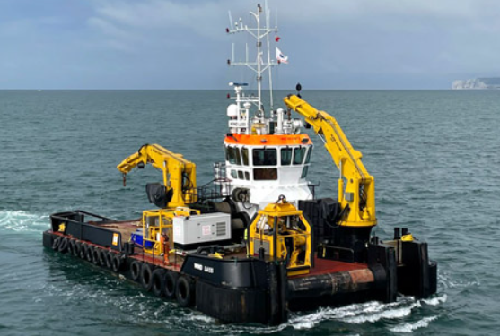
Figure 11: Wind Lass
All vessels listed will be restricted in their ability to manoeuvre when towing and on operations in the works area, and will display the signals prescribed by the International Regulations for Preventing Collisions at Sea, 1972 (as amended). Vessels are requested to pass at a safe speed and maintain a safe distance from all these operations. All vessels will keep a listening watch on VHF channel 16 with a working channel of 17.
These works will be undertaken by KierBAM JV on behalf of NNB Generation Company (Hinkley Point C).
Further enquiries should be addressed to:
Robert Harvey +44 07766 925493 robert.harvey@kierbamhpc.co.uk

Hinkley Point C Harbour Authority
Hinkley Point C, Somerset, TA5 1UF
hpcha@nnb-edfenergy.com www.edfenergy.com/download-centre
Hinkley Point C Notice to Mariners | EDF

