**LOCAL NOTICE TO MARINERS No. 08 OF 2025**

**Hinkley Point C Marine Works**

**Fish Return System Offshore Outfall Head**

**and Tunnel Ramp Installation**

Issued: 18/04/2025

Mariners are advised that from 22/04/2025 until 31/07/25, weather permitting, the vessels listed in the table below will be engaged in the installation of an outfall head and tunnel ramp. This activity forms part of the HPC – Fish Return System offshore scope to allow for the installation of the concrete outfall tunnel headwall structure. This work is in the NE vicinity of HPC Harbour limits, as shown on the chart extract.

**List of Vessels and details are as per below:**

|  |  |  |  |  |
| --- | --- | --- | --- | --- |
| **Name** | **Type of Vessel** | **Call Sign** | **MMSI Number** | **Length(m)** |
| Haven Sea Challenger | JUB | MJQJ2 | 232037256 | 50 |
| JU3620 | JUB | PCAY | 244099000 | 36.5 |
| JU2417 | JUB | N/A | N/A | 24.38 |
| Aquatic Warrior | Works Vessel - Tug | MRNF9 | 232059056 | 20.7 |
| Ocean Energy | Works Vessel - Tug | MNKI5 | 232046909 | 23.33 |
| Ocean Shoalbuster | Works Vessel - Tug | MGLQ2 | 235021947 | 26.21 |
| Ocean Transfer | Crew Transfer Vessel | MDNG8 | 232016908 | 7.4 |
| Nearshore Explorer | Survey Vessel | MGHD9 | 235021512 | 19.5 |

**Location Plan: Q(3)G.6s - Admiralty 1152**

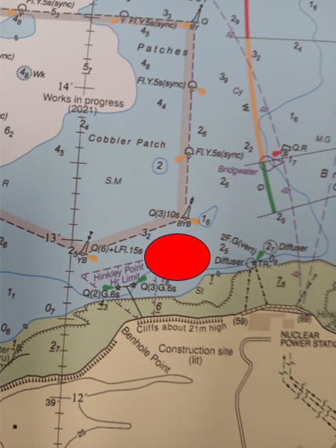

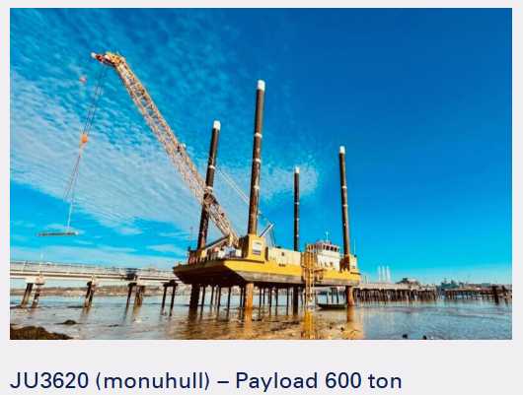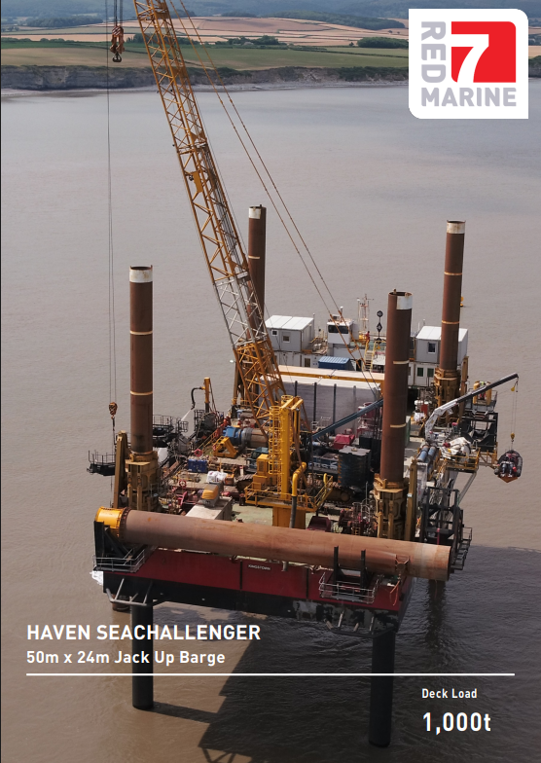*Figure 1: Haven SeaChallenger Figure 2: JU3620 JUB*

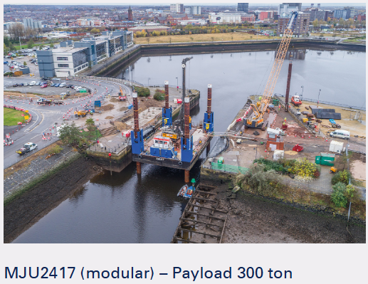*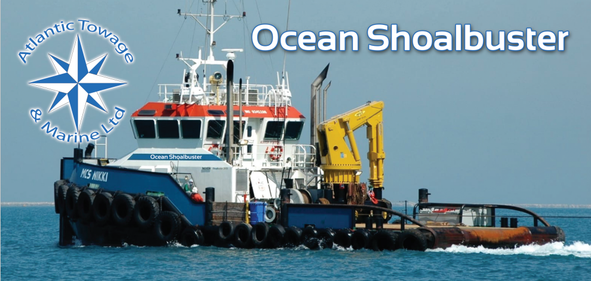Figure 3: JU2417 JUB Figure 4: Ocean Shoalbuster*

*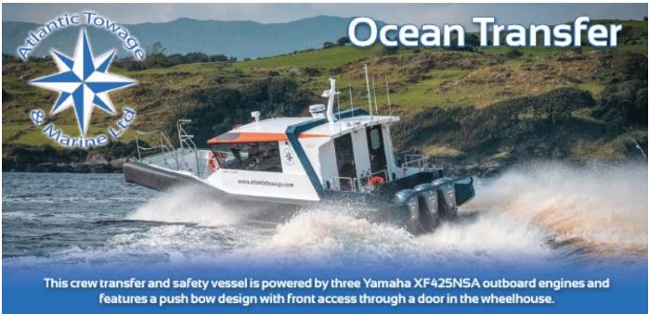Figure 5: Ocean Battler Figure 6: Ocean Transfer*

*Figure 7: Ocean Energy Figure 8: Nearshore Explorer Survey Vessel*

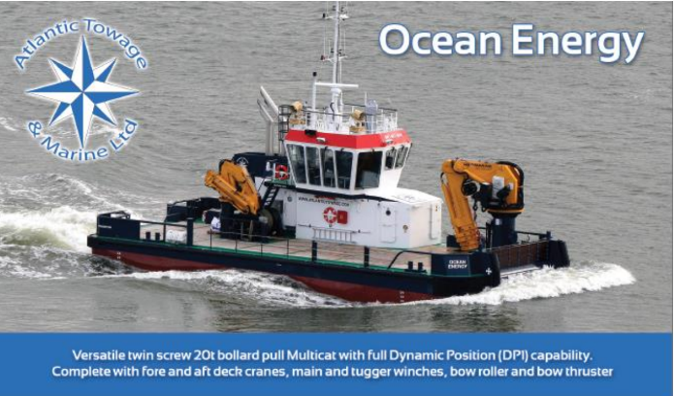

All vessels listed will be restricted in their ability to manoeuvre when towing and on operations in the works area, and will display the signals prescribed by the International Regulations for Preventing Collisions at Sea, 1972 (as amended). Vessels are requested to pass at a safe speed and maintain a safe distance from all these operations. All vessels will keep a listening watch on VHF channels 87 & 16.

These works will be undertaken by KierBAM JV on behalf of NNB Generation Company (Hinkley Point C).

Further enquires should be addressed to:

KierBAM: Stuart Parker +44 07795 196783 stuart.parker@kierbamhpc.co.uk

JV Ocean Energy: Ian Harrington +35 (0)3863677459 ian@atlantictowage.com

Nearshore Survey: Steven Foster +44 (0)7425623377 [stevanfoster@nearshoresurvey.co.uk](mailto:stevanfoster@nearshoresurvey.co.uk)

This LNtM will expire on 31 July 2025.

Harbour Master – Hinkley Point C Harbour Authority

**Issued on behalf of KBJV**

EDF Energy - Nuclear New Build, Hinkley Point C, Somerset, TA5 1UF

Tel. **0333 009 7070** (24hr)

[hinkley-enquiries@edf-energy.com](http://www.edfenergy.com)

[www.edfenergy.com](http://www.edfenergy.com)/download-centre