**LOCAL NOTICE TO MARINERS No. 02 OF 2025**

**Hinkley Point C** **Marine Works Offshore Area –**

**Aids to Navigation Maintenance**

Issued: 05/02/2025

Mariners are advised that on 6 February 2025, maintenance will be conducted on the HPC Aids to Navigation (cardinal marks) marking the marine works (*works in progress*) area at sea, see below chart extract, as described below:

**North & West Hinkley cardinal buoy (CB2N & CB5W) recovery for maintenance - temporary absence.**

* **Date:** Recovery date (from) 06/02/25 - weather permitting
* **Vessel:** Alec-D
* **Master:** Gareth Cox
* **Operation:**  Recovery of North & West Hinkley cardinal buoy (CB2N & CB5W highlighted below) back to shoreside for maintenance works. Buoyage is estimated to remain absent for up to 2 weeks (depending works required) and will be re-deployed at the earliest opportunity.

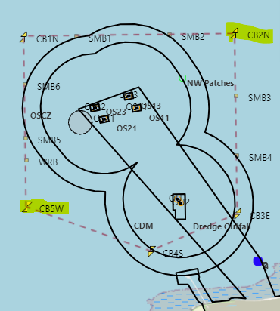

Chart extract identifying the HPC Marine Works Area buoy locations.

The vessel “ALEC-D” (as detailed below) will be conducting these works and will be restricted in its ability to manoeuvre during operations.



For any further safety advice, mariners are advised to contact the Duty Harbour Master

This Local Notice to Mariners is self-cancelling.

Harbour Master – Hinkley Point C Harbour Authority

**Issued on behalf of Balfour Beatty – HPC Marine Works Principal Contractor**

EDF Energy - Nuclear New Build, Hinkley Point C, Somerset, TA5 1UF

Tel. **0333 009 7070** (24hr)

[hinkley-enquiries@edf-energy.com](http://www.edfenergy.com)

[www.edfenergy.com](http://www.edfenergy.com)/download-centre