**LOCAL NOTICE TO MARINERS No. 04 OF 2025**

**Hinkley Point C** **Marine Works**

**Fish Return System Offshore Dredging and Gravel Bed Installation**

Issued: 03/03/2025

Mariners are advised that from 07/03/2025 for up to 6 weeks, the vessel Capall Mara and 600m3 split hopper barges will be conducting dredging and gravel bed installation works in the area shown. This activity forms part of the HPC – Fish Return System offshore scope to allow for the installation of the concrete outfall tunnel headwall structure.

**List of Vessels and details are as per below:**

|  |  |  |  |  |
| --- | --- | --- | --- | --- |
| **Name** | **Type of Vessel** | **Call Sign** | **MMSI Number** | **Length(m)** |
| Capall Mara | Backhoe Dredger | MBSF3 | 232010652 | 39.6 |
| B601 | Unmanned 600m3 split hopper barge | N/A | N/A | 54.02 |
| B602 | Unmanned 600m3 split hopper barge | N/A | N/A | 54.02 |
| Aquatic Warrior | Works Vessel - Tug | MRNF9 | 232059056 | 20.7 |
| Ocean Energy | Works Vessel - Tug | MNKI5 | 232046909 | 23.33 |
| Ocean Shoalbuster | Works Vessel - Tug | MGLQ2 | 235021947 | 26.21 |
| Ocean Transfer | Crew Transfer Vessel | MDNG8 | 232016908 | 7.4 |
| Nearshore Explorer | Survey Vessel | MGHD9 | 235021512 | 19.5 |
| Ocean Battler | TUG | MRNF9 | 232059056 | 19.5 |

Vessel images:

*Figure 1: Capall Mara*

*Figure 2: 600m3 B601/B602 unmanned Split hopper Barges*

*Figure 3: Ocean Shoalbuster*

*Figure 4: Ocean Battler*

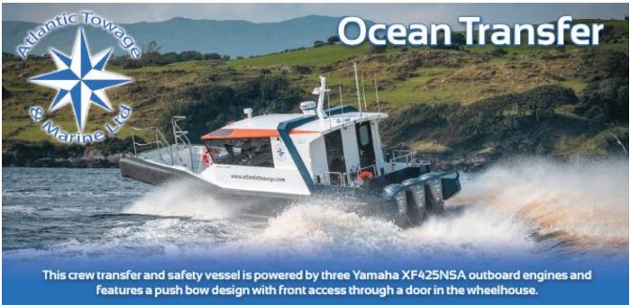

*Figure 5: Ocean Transfer*

*Figure 6: Ocean Energy*

All vessels will be restricted in their ability to manoeuvre and will display the signals prescribed by the International Regulations for Preventing Collisions at Sea, 1972 (as amended). Vessels are requested to pass at a safe speed and maintain a safe distance from all these operations. All vessels will keep a listening watch on VHF channels 87 & 16. Barges will route between the dredge site and Portishead Disposal Site (LU 070). See also The Bristol Port Company LNTM 03 of 2025.

The dredge, disposal, and backfill operations and accompanying hydrographic surveys will be undertaken by KierBAM JV on behalf of NNB Generation Company (Hinckley Point).

Further enquires should be addressed to:

KierBAM: Stuart Parker +44 07795 196783 stuart.parker@kierbamhpc.co.uk

JV Ocean Energy: Ian Harrington +35 (0)3863677459 ian@atlantictowage.com

Nearshore Survey: Steven Foster +44 (0)7425623377 stevanfoster@nearshoresurvey.co.uk

Harbour Master – Hinkley Point C Harbour Authority

**Issued on behalf of KBJV**

EDF Energy - Nuclear New Build, Hinkley Point C, Somerset, TA5 1UF

Tel. **0333 009 7070** (24hr)

[hinkley-enquiries@edf-energy.com](http://www.edfenergy.com)

[www.edfenergy.com](http://www.edfenergy.com)/download-centre