

ANNUAL SAILING REGATTA 2024

Saturday 7th September 2024

**SAILING INSTRUCTIONS**

**(All Classes)**

Version 1.0

SAILING INSTRUCTIONS (SIs)

1 **RULES**

1.1 The event is governed by the rules as defined in the latest revision of *The Racing Rules of Sailing*.

1.2 For Dinghies:

1.21 Rule 40 will be changed as follows: Competitors shall wear personal flotation devices at **all times whilst afloat**, except briefly while changing or adjusting clothing or personal equipment.

1.22 Masthead buoyancy will be allowed for all classes.

1.23 All activities of the regatta will be governed by the current Dinghy Race Risk Assessment (see Appendix 2). In advance of an activity occurring the Safety Officer (where present) will complete the Risk Assessment and submit to the CBYC Dinghy Committee and / or Race Officer for review. Mitigations for High Risk will be put in place far enough in advance to manage unacceptable risks. In the absence of a Safety Officer the Race Officer will complete the Risk Assessment.

1.3 All competitors, that are not CBYC members, will be Temporary members of CBYC for the period of the regatta only and subject to compliance with CBYC Rules and Bye Laws which can be found at [www.cbyc.co.uk](http://www.cbyc.co.uk).

1.4 For Yachts:

IRC Rule 22.4 shall not apply to IRC or NHC fleets. There will be no limitation of crew weight.

1.5 General Data Protection Regulation. At registration competitors will be requested to complete a form giving permission to the Organising Authority to collect and use data about the competitor for the purposes of organising the event. The Organising Authority have in place a data protection policy which is available from the club office.

1.7 Cardiff Bay Yacht Club accept no responsibility or liability for loss of life or Injury to members or others, or for the loss of, or damage to, any vessel or properly.

2 **NOTICES TO COMPETITORS**

Notices to competitors will be posted via the “CBYC Regatta 2024” Whatsapp group that is contained within the Cardiff Bay Yacht Club whatsapp community.

Link to the group is:

<https://chat.whatsapp.com/DP55l8D00MpCfeuwqwv4gJ>

3 **CHANGES IN SAILING INSTRUCTIONS**

Any changes to the sailing instructions (Sis) will be communicated by the Race Officer, using the “CBYC Regatta 2024” whatsapp group, at least 60 minutes before the start of the first race of the day.

4 **CODE OF CONDUCT**

Competitors shall comply with reasonable requests from race officials. Any form of rude, abusive, aggressive or racist behaviour to race officials and other competitors will be considered misconduct and acted upon per RRS 69.

5 **SCHEDULE OF EVENTS**

The schedule will be as defined in the Notice of Race.

6 **SIGNALS MADE**

6.1 Dinghies / TARS / Gaffers / Pursuit Race:

Signals made will be hoisted on the flagpoles, the location of which is on the Committee Boat. Onshore signals, if required, will be hoisted on flagpoles attached to the training centre cabin.

Dinghies General Handicap: Flag F 

Dinghies U18 Fleet: Flag Q

TARS / Gaffers: Flag T

6.2 Yachts:

IRC and NHC Yachts (Channel Races):

All Signals made will be by means of radio communication only on Channel 37a (M1).

7 **COURSES**

7.1 Dinghies / TARS / Gaffers:

The diagrams shown in Appendix 1 show the courses, including the approximate angles between legs, the order in which marks are to be passed, and the side on which each mark is to be left.

The course “letter” & number of laps shall be displayed on the committee boat.

7.2 Yachts:

Courses will be communicated by radio on Channel 37a (M1).

8 **MARKS**

8.1 Marks of the course will be yellow or orange inflatable buoys.

8.2 The starting mark will be a spherical buoy, preferably with a white pole through it which may be topped with a flag.

8.3 An orange flag will be used to signal the committee boat end of the start line.

9 **THE START**

9.1 Races will be started using RRS 26 with the warning signal made 5 minutes before the starting signal.

9.2 The starting line is between mast on the committee boat and the start mark.

9.3 A boat that does not start within 10 minutes after her starting signal may be scored Did Not Start without a hearing. This changes RRS Appendix A, A5.

9.4 Races will be started as follows. Times shall be taken from the visual signals; the absence of any sound signal shall be disregarded.

|  |  |  |  |  |
| --- | --- | --- | --- | --- |
| **Time** | **Signal** | | **Number of sound signals** |  |
| -5 | Warning | Class flag ‘F’ or “Q” | 1 | h CLASS FLAG |
| -4 | Preparatory displayed | Flag ‘P’ or  Flag ‘U’ or “black” | 1 | h A picture containing shape  Description automatically generated (P)  or  h Shape, square  Description automatically generated (U)  or  h Black |
| -1 | Preparatory removed | | 1 | i A picture containing shape  Description automatically generated (P)  or  i Shape, square  Description automatically generated (U)  or  i Black |
| 0 | Start | Class flag removed | 1 | i CLASS FLAG |

9.5 Individual Recalls - If, at the starting signal, any part of any boat or any crew are on the course side of the starting line the ‘X’ Flag will be flown and a single sound signal shall be made to draw attention to the flag. Where possible the boat may be informed.



9.6 General Recalls - If there are a number of unidentified premature starters or an error in the starting procedure identified after the starting signal the ‘First Substitute’ flag will be flown with a double sound signal.

9.7 New Start After General Recall - The starting sequence will recommence the sooner of either as soon as possible after the general recall has been observed, or on the start signal of another fleet, but no sooner than 1 minute after the lowering of the general recall flag.

9.8 Dinghies only : Dependent on the numbers of participants, the Race Officer can add or remove a separate start for U18 sailors. If added the ‘Q’ flag will be used for the U18 start and the general handicap start signal will be the warning signal for the U18 fleet. Details will be confirmed in the briefing.

9.9 If all racing is abandoned for the day the ‘N’ Flag will be flown with a repeating sound signal. All participants must return to shore.



10 **CHANGE OF THE NEXT LEG OF THE COURSE**

To change the next leg of the course, the race committee will move the original mark or the finishing line to a new position.

For Channel Races the Race Officer will announce any change to the next leg of the course by radio communication.

11 **THE FINISH**

The finishing line is between the mast on the committee boat, which may be displaying a blue flag, and the finish mark.

12 **TARGET TIMES**

12.1 The target time is for most boats racing to finish after approximately 45 minutes.

12.2 Boats shall be finished as close to the target time in 12.1 as practical with average laps being applied for boats finishing on different laps.

12.3 The race officer should aim to avoid finishing boats of the same class on different laps, unless there is a significant gap between boats of the same class.

12.4 The Race Officer will have the discretion to finish any boats that are a significant way behind the leaders, such that the race officer can then start the next race of the day in good time. Any boats finished early will be awarded positions in the order they are finished by a race committee boat flying the ‘W’ flag (these positions will be scored in the results after normal finishers).

13 **HEARING REQUESTS**

13.1 The protest time limit is *1* hour after the last boat finishes the last race of the day for the class it is sailing in.

13.2 Hearing request forms are available from the notice board at CBYC or from the RYA website.

13.3 When a protest or request for redress is lodged, a boat may at the same time request an Advisory meeting or RYA Arbitration, or the Protest Committee or Race Committee may offer it, as per the RYA guidelines.

https://www.ncsc.org.uk/wp-content/uploads/2022/03/78f_RYA_Guidance_-_Rules_Disputes_Poster-Jan-2022.pdf

13.4 Hearing request forms shall be sent to the race officer or a member of the sailing committee. The sailing committee will then organise to deal with the hearing and inform all relevant parties.

13.5 The outcomes of any hearing will be published on the “CBYC Regatta 2024” Whatsapp group.

14 **EXONERATION PENALTY**

14.1 A boat that may have broken a rule of Part 2, rule 31 or rule 42, may, after finishing the race concerned and before the start of a related protest hearing, notify the Race Committee that it accepts a 30% scoring penalty as stated in rule 44.3(c), except that the minimum penalty is two places provided that does not result in a score worse than DNF. This penalty does not reverse an OCS score, a disqualification under rule 30.3 or a penalty under Appendix P. It is not available for a breach of rule 2 or of class rules or for gross misconduct under rule 69. Nor is it available to a boat that caused injury or serious damage or gained a significant advantage by her breach: in these circumstances, her penalty is to retire.

15 **SCORING**

15.1 The minimum number of boats for a race to count is 3.

15.2 (a) When fewer than 3 races have been completed, a boat’s regatta score is the total of her race scores.

(b) When 3 races have been completed, a boat’s regatta score is the total of her race scores excluding her worst score.

15.4 If numbers allow, dinghy sailors under the age of 18 at the start of the regatta will have separate “U18” fleet results. U18 sailors must complete a parental consent form (copies can be downloaded from the CBYC website) and provide to the CBYC Dinghy Committee or Race Officer prior to racing.

15.5 Rule A5.3 applies.

15.6 Dinghy Handicaps used shall be taken from the current RYA National Portsmouth Number list. This list is available from the RYA’s website: [www.RYA.org.uk/racing/Pages/portsmouthyardstick.aspx](http://www.RYA.org.uk/racing/Pages/portsmouthyardstick.aspx)

Yacht Handicaps shall be taken from valid IRC certificates or current NHC ratings.

Pursuit Race handicaps shall be taken from the current RYA National Portsmouth Number list. If a boat does not appear on the list it shall be assigned an appropriate PY at the discretion of the Race Officer

15.7 Where the class, or a boat within a class, is not sailed in accordance with class rules, or is not listed on the RYA PN list, the Race officer, as he sees applicable, shall have the option to assign the class, or boat, a handicap number based on known performances to similar fleets or based on other methods as consulted with the RYA technical team. This does not apply to yachts competing in the IRC class, where such yachts must have a valid IRC certificate.

15.8 The handicaps used shall not be adjusted for the duration of the regatta and in the event that a boat within a class is not sailed in accordance with class rules in a race within a series then the competitor shall have the option of using the assigned handicap and having the race separately scored for such races within the series or alternatively being scored DNF for the race.

16 **RUBBISH DISPOSAL**

Boats shall not put rubbish into the water. Rubbish should be retained on the boat and disposed of on-shore.

17 **REPLACEMENT OF CREW OR EQUIPMENT**

17.1 If a boat’s helm changes the race score will count as a separate entry in the regatta except in the case of established helm and crew combinations that can switch roles.

17.2 A boat can have different crews. This will count as one entry in the regatta.

18 **EQUIPMENT AND MEASUREMENT CHECKS**

A boat or equipment may be inspected at any time for compliance with the class rules, notice of race, sailing instructions or any other safety rules as defined by the host authority.

19 **RISK STATEMENT**

RRS 3 states: ‘The responsibility for a boat’s decision to participate in a race or to continue to race is hers alone.’ By participating in this event each competitor agrees and acknowledges that sailing is a potentially dangerous activity with inherent risks. These risks include strong winds and rough seas, sudden changes in weather, failure of equipment, boat handling errors, poor seamanship by other boats, loss of balance on an unstable platform and fatigue resulting in increased risk of injury. **Inherent in the sport of sailing is the risk of permanent, catastrophic injury or death by drowning, trauma, hypothermia or other causes.**

When the race committee considers that a boat or competitor is in difficulty it may instruct the boat or competitor to accept outside help, retire or sail ashore.

20 **INSURANCE**

Each participating boat shall be insured with valid third-party liability insurance with a minimum cover of £3 million per incident or the equivalent.

**Appendix 1**

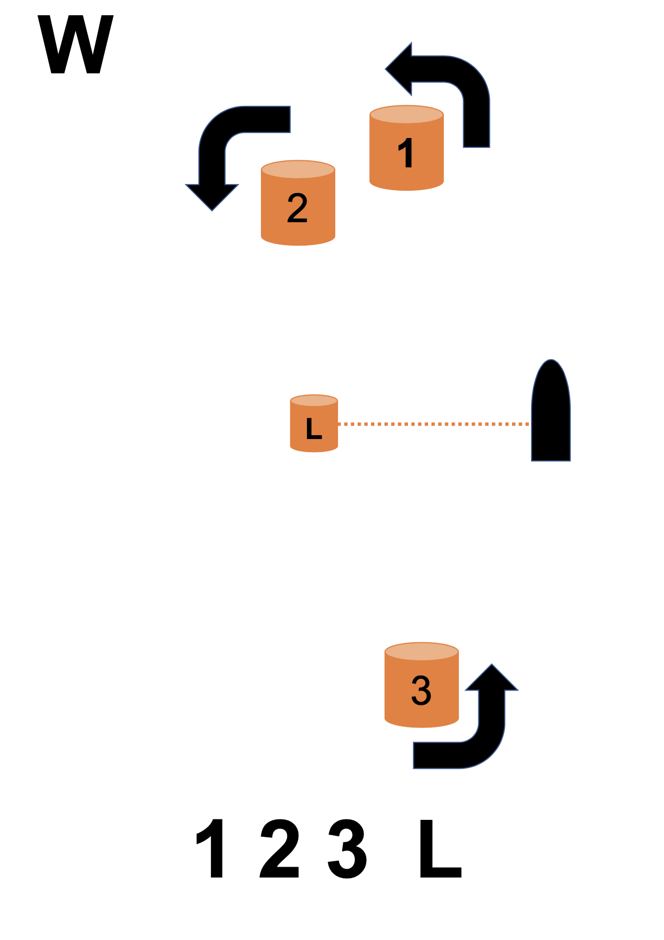Boats must pass through the start / finish line on each windward leg

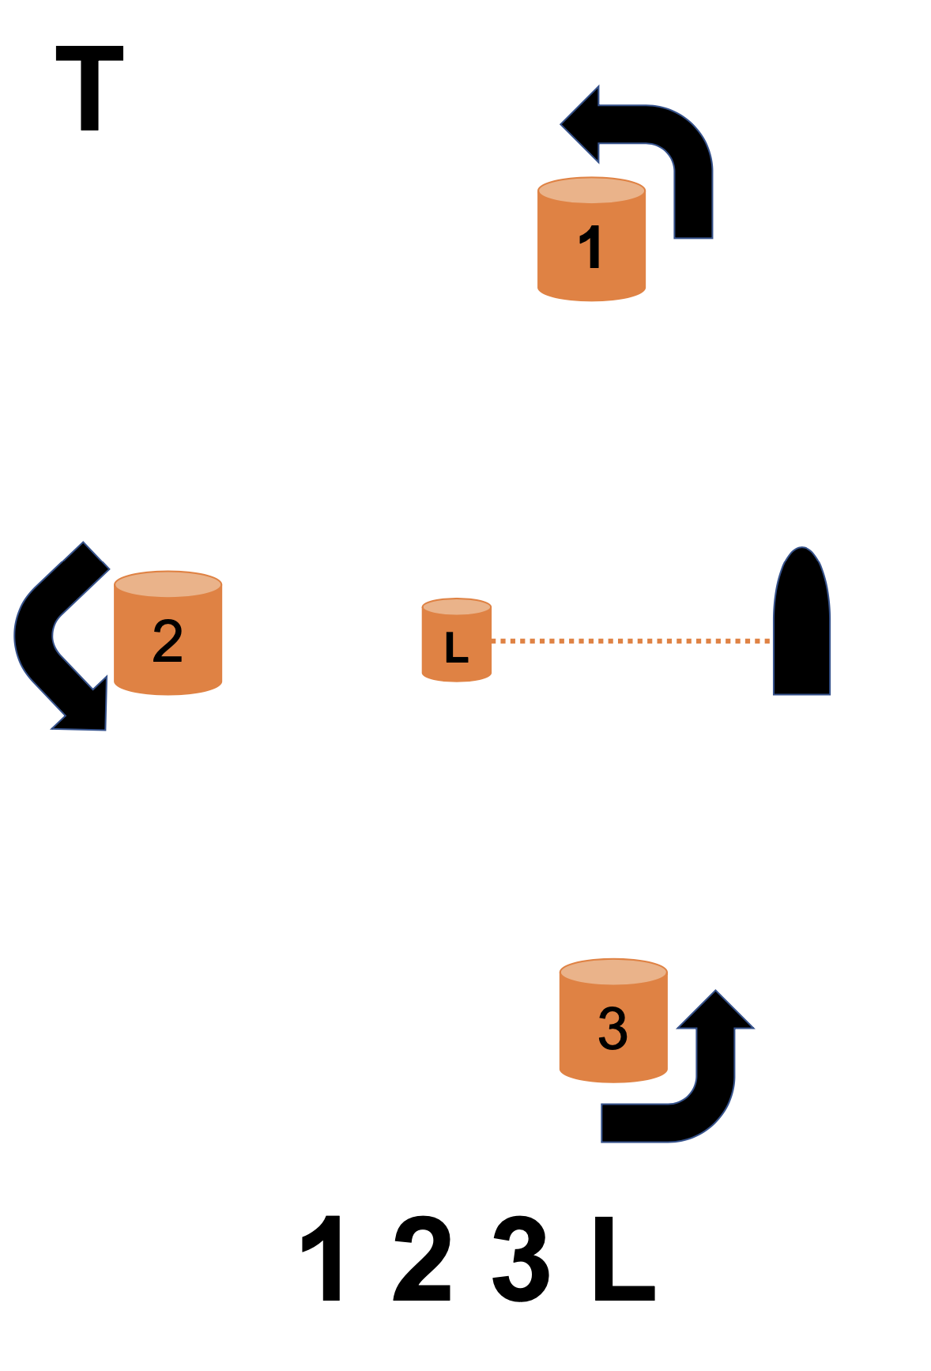 Boats must pass through the start / finish line on each windward leg

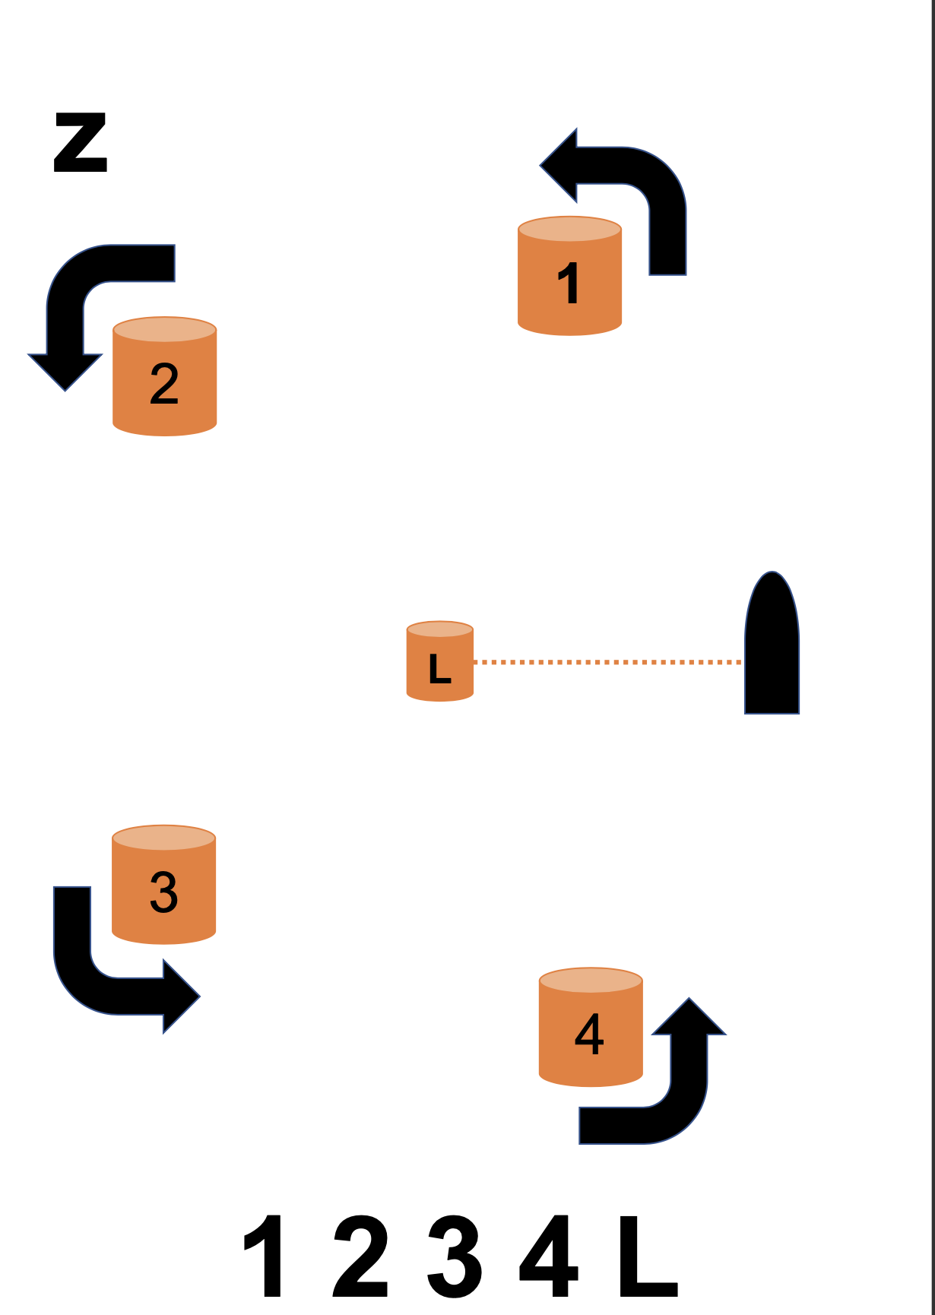

Boats must pass through the start / finish line on each windward leg

|  |  |  |  |  |  |  |
| --- | --- | --- | --- | --- | --- | --- |
| **Appendix 2**  **CBYC DINGHY RACE RISK ASSESSMENT SHEET** | | | | |  | |
|  |  |  |  |  |  | |
| **Safety Boat Cover Ratio** | |  | **Wind Conditions** | |  | |
|  |  |  |  |  |  | |
| Number of boats | Risk Rating |  | Knots | Risk Rating |  | |
| 1-6 | 1 |  | 0-5 | 0 |  | |
| 7-10 | 2 |  | 6-10 | 1 |  | |
| 11-20 | 3 |  | 11-15 | 2 |  | |
| 21-30 | 5 |  | 16-20 | 4 |  | |
|  |  |  | 20-25 | 5 |  | |
|  |  |  | Over 25 | 9 |  | |
| 2 OR MORE SAFETY BOATS HALF THE POINTS | |  | KTS REFERS TO MAXIMUM GUST |  |  | |
|  |  |  |  |  |  | |
| **Enter Safety Boat Cover Risk Number** | |  | **Enter Wind Condition Risk Number** | |  | |
|  |  |  |  |  |  | |
|  |  |  |  |  |  | |
| A |  |  | B |  |  | |
|  |  |  |  |  |  | |
| **Water Quality Predictions** | |  | **Visibility** | |  | |
|  |  |  |  |  |  | |
| Water Quality | Risk Rating |  | Visibility Level | Risk Rating |  | |
| Pass | 0 |  | Good | 0 |  | |
| Fail (+ capsize immersion unlikely) | 2 |  | Low | 2 |  | |
| Fail (+ risk of capsize immersion) | 9 |  | Unable to see the Barrage from the top of the slipway | 9 |  | |
| https://www.cardiffharbour.com/water-quality-forecast/ |  |  |  |  |  | |
| **Enter Water Quality Predictions Risk Number** | |  | **Visibility Condition Risk Number** | |  | |
|  |  |  |  |  |  | |
| C |  |  | D |  |  | |
|  |  |  |  |  |  | |
| **Date** |  | **Race Officer** | | **TOTAL Risk Number (A+B+C+D)** | | |
|  |  |  |  |  |  | |
|  |  |  |  |  |  | |
|  |  |  |  |  |  | |
|  |  |  | **Under 10 is a Manageable Risk** | | |